Unbiased Sensor Bridge Connection

# 

# Introduction

This article shows a cheap unbiased sensor biasing. This is not the cheapest solution.

Applications for the circuit include sensors that do not need biasing:

* ultrasonic sensors,
* certain vibration/motion detection sensors (not all),
* coil sensors (metal detectors),
* ECG (Electrocardiogram),
* and EEG (Electroencephalogram).

I invented this circuit after reading those articles:

<https://www.instructables.com/Biased-Sensor-Bridge>

<https://hackaday.io/page/9398-biased-sensor-bridge>

# Step 1: Design the Circuit

The circuit design is very simple:

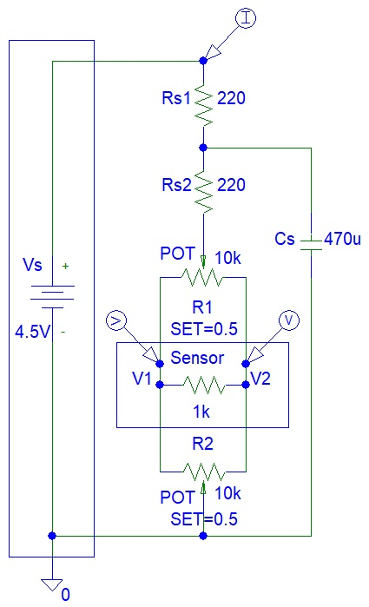

**Figure 1:** Circuit Design

I tried to reduce the cost by using the same resistor value for Rs1 and Rs2. The cost of my circuit could be further reduced by eliminating the Rs2 resistor and Cs capacitor. However, then you are allowing power supply oscillations to propagate through the amplifier.

Calculate the maximum power supply current:

Ismax = Vs / Rs

= 4.5 V / 220 ohms

= 0.02045454545 A

= 20.45454545 mA

The maximum current value cannot be ignored. You could be damaging the power supply.

# Step 2: Simulations

Simulations show maximum input current:

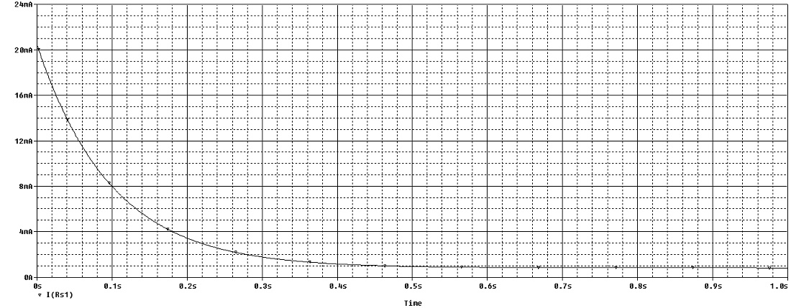

**Figure 2:** PSpice Transient Simulations

# Conclusion

This article showed you how my circuit is working. I suggest that you click on the links and read the other articles about biasing sensors.

# 

# References

1. <https://www.instructables.com/Biased-Sensor-Bridge>
2. <https://hackaday.io/page/9398-biased-sensor-bridge>